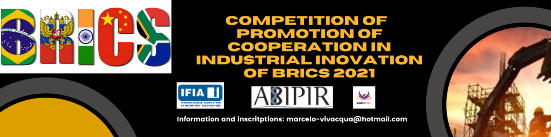

PROJECT APPLICATION FORM FOR 2021 COMPETITION ON PROMOTING BRICS INDUSTRIAL INNOVATION COOPERATION

I. The information of the institution /University/Company/Startup/inventor responsible for the project
Name
Contact Person
II. Overview of the Project
(including but not limited to, the project’s title, the authors and their contact information, and the general description of the project as problem which will be solved, market potential, stage of development etc)
III. Specific Documents of the Project
(Specific documents can be prepared under the three categories of the Competition, i.e, creative design, creative products, and innovative entrepreneurship projects. The documents include but not limited to, project technical solutions, project feasibility reports, product design ideas or solutions, and related research papers, links for videos etc.The documents can be submitted as attachment to this form.)

ABOUT THE COMPETITION

1. The competition invites a wide range of projects from BRICS countries. Participants can be government agencies, enterprises, startups, vocational schools, universities, teachers, students, etc., applying in the name of organization or individual;

2. Works or Entries: It can be innovative products, applications, ideas, standards, initiatives, solutions or projects focusing on the next generation of communication technology, industrial Internet, intelligent manufacturing, green recycling and low-carbon fields. Projects can be the one that have been completed, projects that are ready to be implemented, or projects that are being implemented.

3. Procedure: Participants should fill in the application form and submit it until August 13th. After the jury review, the finalists will be selected and publicized. In the finals in early September, the participant of finalistic project will conduct the presentation and defense through remote mode, and the international outstanding ones will receive e-certificates.

4. The award ceremony will be held at the third BRICS Partnership for New Industrial Revolution Forum about Sep. 7th, which depends on how the regional pandemic develops. The international winners will be able to participate via remote mode.

Please send the applciation form the followed e-mail and report any issues related to participation in the Competition:
Marcelo Vivacqua: marcelo-vivacqua@hotmail.com

